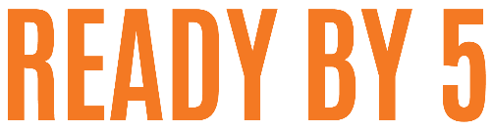
Childcare Request for Payment
This form should be filled out at the end of the workshop and submitted to United Way for payment.
Payment is only made on the 15th and 30th of the month. Requests submitted before the 10th of the month will be paid out on the 15th. Requests submitted by the 25th of the month will be paid out on the 30th.

Ready by 5 Workshop Location: Childcare Provider’s Name:

Please select one:
I have filled out and submitted the direct deposit info
Please mail my check
Address for check to be sent:

 | Date of Workshop | Hours  Worked
1
2
3
4
5
 | Total Hours Worked
 | Rate of Pay | $18/hr
 | Total of Request

Signature of Facilitator:

