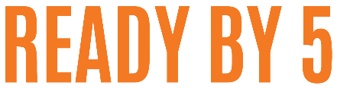
Facilitator Payment Agreement

United Way Quad Cities agrees to pay Facilitator Name, by the following schedule in exchange for the facilitation and coordination of the Ready by 5 Parent Workshop from start to end.

By this agreement, it is agreed that payment in the amount of $1200 will be paid at the completion of the workshop. This is based on the expectations listed on the job description.

Payment will be received through direct deposit and a 1099 will be sent out at the end of the year. A direct deposit form must be filled out and on file with United Way. Workshops that end before the 10th of the month will be paid out on the 15th of that month. Workshops that end before the 25th will be paid out on the 30th.

By signing this agreement, both parties agree to the terms as described above. Alterations to this agreement can only be made by both parties and must be placed in writing. Both parties will receive a copy of this agreement, and will be responsible for upholding its items.

READY BY 5 FACILITATOR DATE

Natalie Rohrer

READY BY 5 COORDINATOR, UNITED WAY DATE

